Recap from todays session
One to One Many relationships can be traced by a person who creates a database.
One to One Many Relationships
- Teacher to many students.
- Jobs to Workers.
- Same investment can be made by clients.
- A single shop can have many products.
- Countries has one to one Relationship.

SQL JOINS
- How to understand the Join based on the diagram?
- This is the right join.
- When I am work with Inner Join those records will be returned to me.
- I can do the right Inner Join and exclude the left Inner Join.
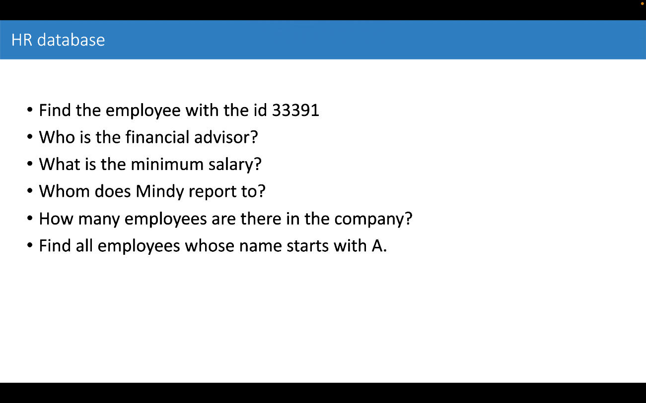
Q1 SELECT FROM
Q2 Nisse Voysey
Q3 32179
Q4 Yovonnda Magrannell
Q5 20 Q6 Alaster

